**Chapter 2**

**Vectors in Space**

**2.7 Cylindrical and Spherical Coordinates**

**Section Exercises**

**Use the following figure as an aid in identifying the relationship between the rectangular, cylindrical, and spherical coordinate systems.**

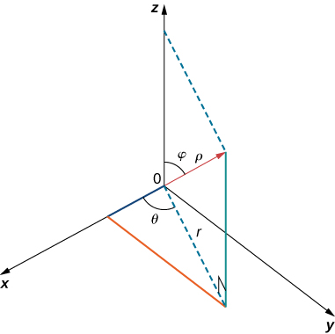

**For the following exercises, the cylindrical coordinates  of a pointare given. Find the rectangular coordinates  ofthe point.**

363. 

Answer: 

365. 

Answer: 

**For the following exercises, the rectangular coordinates  of a pointare given. Find the cylindrical coordinates  of the point.**

367. 

Answer: 

369. 

Answer: 

**For the following exercises, the equation of a surface in cylindrical coordinates is given.**

**Find the equation of the surface in rectangular coordinates. Identify and graph the surface.**

371. [T]

Answer: A cylinder of equation  with its center at the origin and rulings parallel to the axis,

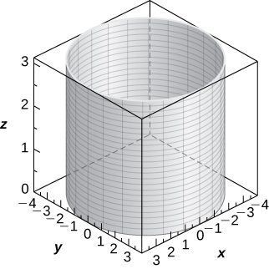

373. **[T]** 

Answer: Hyperboloid of two sheets of equation  with the axis as the axis of symmetry,

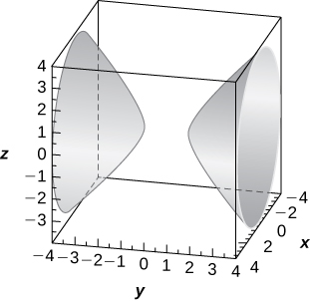

375. **[T]** 

Answer: Cylinder of equation  with a center at  and radius  with rulings parallel to the  axis,

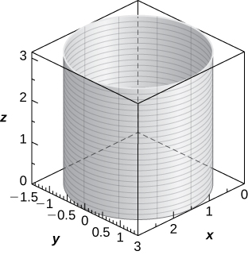

377. **[T]** 

Answer: Plane of equation 

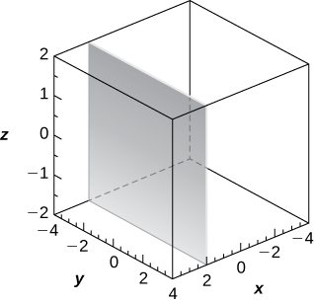

**For the following exercises, the equation of a surface in rectangular coordinates is given. Find the equation of the surface in cylindrical coordinates.**

379. 

Answer: 

381. 

Answer: 

383. 

Answer: 

**For the following exercises, the spherical coordinates  of a pointare given. Find the rectangular coordinates  of the point.**

385. 

Answer: 

387. 

Answer: 

**For the following exercises, the rectangular coordinates  of a pointare given. Find the spherical coordinates  ofthe point. Express the measure of the angles in degrees rounded to the nearest integer.**

389. 

Answer: 

391. 

Answer: 

**For the following exercises, the equation of a surface in spherical coordinates is given. Find the equation of the surface in rectangular coordinates. Identify and graph the surface.**

393. **[T]** 

Answer: Sphere of equation  centered at the origin with radius 

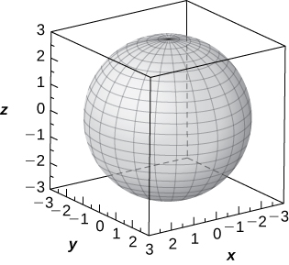

395. **[T]** 

Answer: Sphere of equation  centered at  with radius,

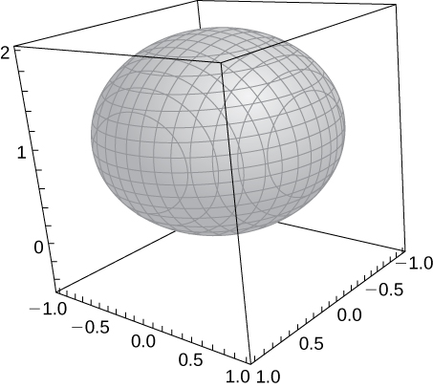

397. **[T]** 

Answer: The plane of equation 

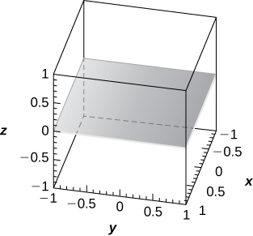

**For the following exercises, the equation of a surface in rectangular coordinates is given. Find the equation of the surface in spherical coordinates. Identify the surface.**

399.  

Answer:  or  Elliptic cone

401. 

Answer:  Plane at 

**For the following exercises, the cylindrical coordinates of a pointare given. Find its associated spherical coordinates, with the measure of the angle  in radians rounded to four decimal places.**

403. **[T]** 

Answer: 

405. 

Answer: 

**For the following exercises, the spherical coordinates of a pointare given. Find its associated** **cylindrical coordinates**.

407. 

Answer: 

409. 

Answer: 

**For the following exercises, find the most suitable system of coordinates to describe the solids.**

411. The solid situated in the first octant with a vertex at the origin and enclosed by a cube of edge length  where 

Answer: Cartesian system, 

413. A solid inside sphere  and outside cylinder 

Answer: Cylindrical system, 

415. **[T]** Use a CAS to graph in cylindrical coordinates the region between elliptic paraboloid  and cone .

Answer: The region is described by the set of points .

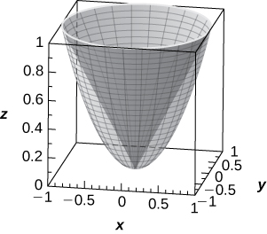

417. Washington, DC, is located at  N and  W (see the following figure). Assume the radius of Earth is  mi. Express the location of Washington, DC, in spherical coordinates.

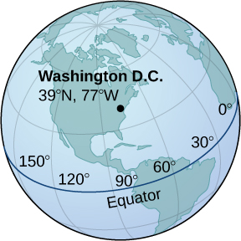

Answer: 

419. Find the latitude and longitude of Rio de Janeiro if its spherical coordinates are 

Answer:  

421. **[T]** Consider the torus of equation  where 

1. Write the equation of the torus in spherical coordinates.
2. If  the surface is called a *horn torus*. Show that the equation of a horn torus in spherical coordinates is 
3. Use a CAS to graph the horn torus with  in spherical coordinates.

Answer: a. , 

c.

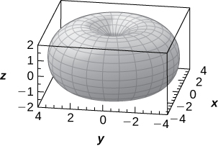

**Chapter Review Exercises**

**For the following exercises, determine whether the statement is true or false. Justify the answer with a proof or a counterexample.**

423. For vectors and and any given scalar  

Answer: True

425. The symmetric equation for the line of intersection between two planes  and  is given by 

Answer: False

**For the following exercises, use the given vectors to find the quantities**.

427. 

1. 
2. 
3. 
4. 

Answer: a. b.  c. Can’t dot a vector with a scalar; d. 

429. Find the values of  such that vectors  and  are orthogonal.

Answer:

**For the following exercises, find the unit vectors.**

431. Find the unit vector that has the same direction as vector  that begins at  and ends at 

Answer: 

**For the following exercises, find the area or volume of the given shapes.**

433. The parallelepiped formed by  and 

Answer: 

**For the following exercises, find the vector and parametric equations of the line with the given properties.**

435. The line that passes through points  and 

Answer:

**For the following exercises, find the equation of the plane with the given properties.**

437. The plane that passes through points 

Answer:

**For the following exercises, find the traces for the surfaces in planes  Then, describe and draw the surfaces.**

439. 

Answer: trace:  is a circle,  trace:  is a hyperbola (or a pair of lines if   trace:  is a hyperbola (or a pair of lines if  The surface is a cone.

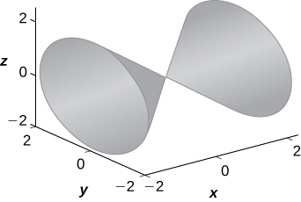

**For the following exercises, write the given equation in cylindrical coordinates and spherical coordinates.**

441. 

Answer: Cylindrical:  spherical: 

**For the following exercises, convert the given equations from cylindrical or spherical coordinates to rectangular coordinates. Identify the given surface.**

443. 

Answer:  sphere

**For the following exercises, consider a small boat crossing a river.**

445. When the boat reaches the shore, two ropes are thrown to people to help pull the boat ashore. One rope is at an angle of  and the other is at  If the boat must be pulled straight and at a force of  find the magnitude of force for each rope (see the following figure).

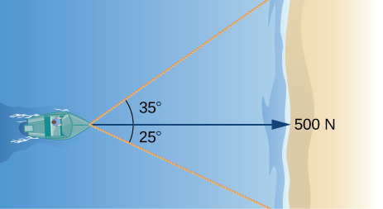

Answer: 331 N, and 244 N

447. Calculate the work done by moving a particle from position  to  along a straight line with a force 

Answer: 

**The following problems consider your unsuccessful attempt to take the tire off your car using a wrench to loosen the bolts. Assume the wrench is  m long and you are able to apply a -N force.**

449. Someone lends you a tire jack and you are now able to apply a -N force at an  angle. Is your resulting torque going to be more or less? What is the new resulting torque at the center of the bolt? Assume this force is not enough to loosen the bolt.

Answer: More,  J

This file is copyright 2016, Rice University. All Rights Reserved.